**Chapter 1**

**INTRODUCTION**

**1.1 Introduction**

In the realm of physical fitness, the correct execution of exercises is paramount for both efficacy and safety. An improper posture during gym and yoga sessions not only diminishes the potential benefits of the workout but also poses a risk of injury. Recognizing the importance of addressing this issue, our project endeavors to perfect the form of gym and yoga exercises through the integration of cutting-edge technology.

The foundation of our approach lies in the utilization of the Pose model from the Mediapipe library, a powerful tool capable of detecting the intricate landmarks or joints of the human body and the connections between them. These landmarks serve as crucial indicators of body parts such as hands, legs, elbows, shoulders, and hips. By accurately capturing the spatial relationships between these landmarks, we can calculate the angles formed by the connections, providing us with a comprehensive understanding of the user's body posture.

This project aims to develop software that focuses on assisting people in properly performing workout such as bicep curl and sit-up using Artificial Intelligence with Computer Vision technique. The goal of this project is to help prevent injuries and improve the quality of individual's workout by providing personalised feedback on their posture using only a computer and a webcam. Artificial Intelligence has always been discussed nowadays due to its ability to assist human with their daily activities. The capabilities of Artificial Intelligence giving humans hope to develop machines with human intelligence. One of the common Artificial Intelligence technologies is called Computer Vision, where machines can recognise photographs and videos in the same way that humans do.

Computer vision is a branch of Artificial Intelligence that aims to teach computers to see, identify, and interpret images in the same way that humans do, and then produce appropriate outputs. In other words, it combines a computer with human intelligence and sensibilities. Image classification, image localization, object detection, segmentation, and keypoint detection are some of the tasks included in computer vision.

**1.2 Purpose**

The primary purpose of our project is to develop a system that acts as a vigilant guide, assisting users in maintaining correct exercise postures. Aiming to enhance the overall exercise experience, our system employs a proactive approach by setting threshold values for key angles involved in various exercises. These threshold values are determined through a meticulous study of ideal exercise angles, ensuring that users receive immediate alerts when deviating from the prescribed form.

**1.3 Aim**

The overarching aim of our project is to contribute to the creation of a safer and more effective exercise environment. The specific objectives include:

* Implementing the Pose model to detect body landmarks and connections.
* Calculating relevant angles between body connections for various exercises.
* Establishing threshold values based on ideal exercise angles.
* Providing real-time alerts to users when their posture exceeds the defined thresholds.
* Empowering users to correct their form and reduce the risk of injuries.

**1.4** **Objective**

The goal of this project is to develop an Artificial Intelligence-based system that assists people in performing home workouts such as bicep curl and sit-up by combining computer vision technology with human pose estimation technique, along with deep learning and machine learning approaches.

Following are the objectives of this project in order to achieve the mentioned goals:

* To investigate how computer vision can assist in detecting human exercise posture and incorrect posture.
* To develop an artificial intelligence-based software that uses camera to detect user’s workout posture and provides personalized feedback on improving their exercise posture. 3
* To help preventing injuries and breaking the bad habits of exercising with incorrect posture.
* To evaluate the effectiveness of implementing this software in individual’s health.

**1.5 Scope**

While our current focus is on perfecting exercise form through real-time feedback, the scope of our project extends beyond its immediate applications. In the future, we envision integrating an exercise and diet planner into the system, providing users with a comprehensive tool for optimizing their fitness routines.

As we delve into the subsequent sections, we will explore the technological and methodological aspects of our project, detailing the steps taken to transform this vision into a functional and user-friendly solution. Through this initiative, we aspire to contribute to the advancement of fitness technology and promote safer, more effective workout practices.

**Chapter 2**

**LITERATURE SURVEY**

The paper discusses the challenges of human pose estimation in computer vision, highlighting factors such as image scale, lighting changes, and cluttered backgrounds. It emphasizes the difficulty of automatically detecting a person's pose in an image due to various influencing factors. The paragraph references a method proposed by Yamakawa et al. from Waseda University in Tokyo, Japan, aimed at enhancing the accuracy of human pose estimation in videos. This method utilizes time series correlation to handle human pose as a set of time series data. Integration of a CNN-based model with a multiple-object tracking framework is employed to improve detection accuracy, interpolating undetected or incorrectly detected body joints using information from previous and following frames.

|  |  |  |  |  |
| --- | --- | --- | --- | --- |
| **Author** | **Title** | **Year**  **Of**  **Publication** | **Method for Human**  **Pose Estimation** | **Analysis/ Results** |
| Mr.Kalyan D Bamane,  Adarsh Bevore, Shashwat Upadhyay | Body Posture Guiding System | 2020 | . Deep Learning for Posture Analysis in Fall Detection | The work introduced in this paper is mainly focused on investigating a relatively low-cost and reliable fall detection approach for older adults based on computer vision techniques. |
| Ankita Rameshwar Mahajan, Vinod Agrawal | MOVEMENT DETECTION USING OPENCV | 2022 | Movement Detection using python | This Article can also be introduced as a better alternative to the expensive traditional security systems that take up much storage space and are not affordable for everyone. |
| Parag Tirpude, Sagar Sahu, Prof. Harshita Ragite | REAL TIME OBJECT DETECTION USING OPENCV-PYTHON | 2022 | ALGORITHMS FOR OBJECT DETECTION AND TRACKING | The Object Detection system in Images is web based application which mainly aims to detect the multiple objects from various types of images. |

**Chapter 3**

**PROBLEM STATEMENT**

Develop an advanced Posture/Form Perfector System to address the prevalent issue of poor posture and form during everyday activities, leading to various health concerns. The system should encompass multiple major functionalities to provide real-time feedback, exercises, and recommendations, ultimately helping users maintain correct posture and form for improved well-being

**Chapter 4**

**PROJECT REQUIREMENTS**

The project requirements are mentioned in the objectives section earlier, which is to investigate on how computer vision can assist in detecting human exercise posture and incorrect posture. To achieve this, the author must first achieve human pose estimation by using deep learning with CNN-based architecture as it is the common framework that specialized in image processing. The system should then be able to provide personalized feedback on their workout posture by detecting improper posture using various approaches. Machine learning and geometrical approaches are studied to find which approach is capable of achieving he author’s main goal. The selected approaches will be then implemented into a desktop application following the best practices of designing user interface for better user experience.

**Mediapipe pose landmarker**

The MediaPipe Pose Landmarker task lets you detect landmarks of human bodies in an image or video. You can use this task to identify key body locations, analyze posture, and categorize movements. This task uses machine learning (ML) models that work with single images or video. The task outputs body pose landmarks in image coordinates and in 3-dimensional world coordinates.

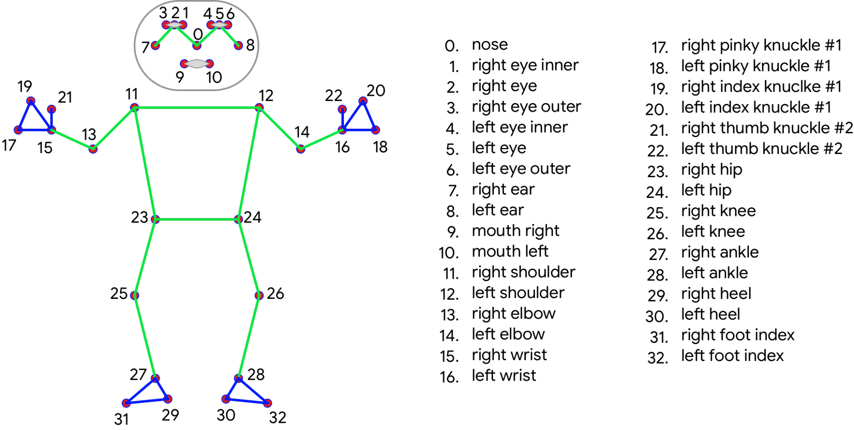The pose landmarker model tracks 33 body landmark locations, representing the approximate location of the following body parts:

Diagram 4.1

**Programming Language & Libraries**

1. Python

Python is a programming language that was created by Guido van Rossum in 1991 and has a simple syntax similar to the English language.



Diagram 4.2

1. OpenCV

OpenCV (Open Source Computer Vision Library) is an open source computer vision and machine learning software library. OpenCV was built to provide a common infrastructure for computer vision applications and to accelerate the use of machine perception in the commercial products. Being an Apache 2 licensed product, OpenCV makes it easy for businesses to utilize and modify the code.



Diagram 4.3

1. MediaPipe

MediaPipe is a Framework for building machine learning pipelines for processing time-series data like video, audio, etc. This cross-platform Framework works on Desktop/Server, Android, iOS, and embedded devices like Raspberry Pi and Jetson Nano.



Diagram 4.4

d. NumPy

NumPy (pronounced NUM-py) is a library for the Python programming language, adding support for large, multi-dimensional arrays and matrices, along with a large collection of high-level mathematical functions to operate on these arrays. We are mainly using this library to calculate the angle between connections.



Diagram 4.5

**Software**

1. Jupyter Notebook

The Jupyter Notebook is the original web application for creating and sharing computational documents. It offers a simple, streamlined, document-centric experience.



Diagram 4.

**Project Planner**

|  |  |  |  |  |
| --- | --- | --- | --- | --- |
| Sr.No. | Dates | | Project Task | Completion Date |
|  | Month | Weeks |  |  |
| 1. | August | Week 0 | Initial Discussion about 3 topics | 1/08/2023 |
| 2. | Presentation of Respective topics to faculty panel | 2/08/2023 |
| 3. | Week 1 | Primary Discussion of Project  Flow, Technologies, Use Cases | 16/08/2023 |
| 4. | Selection of Final Topic and discussion about pros, cons, and future scope with project guide | 29/08/2023 |
| 5. | Week 2 | Problem statement Finalization | 30/08/2023 |
| September | Submission of Problem Statement | 1/09/2023 |
| 6. | Week 3 | Literature Review/ Survey Discussion | 5/09/2023 |
| Project Review 1 |
| 7. | Week 4 | Discussion Regarding Requirements | 9/09/2023 |
| 8. | Week 5 | Requirement Gathering and Analysis | 11/09/2023 |
| 9. | Week 6 | Prototype and Wireframing | 15/09/2023 |
| 10. | Week 7 | Tried Module 1 Implementation | 17/08/2023 |
| 11. | October | Week 8-9 | Initial Coding, made an functions required for our project. | 22/08/2023 |
| 12. | Week 10 | Project Review 2 | 1/08/2023 |
| 13. | Nov/Dec | Week 11-12 | Front end prototype | 14/11/2023 |

**Chapter 5**

**SYSTEM DESIGN**

**Data Flow Diagram (DFD):**

It's easy to understand the flow of data through systems with the right data flow diagram software.

**DFD Level 0:**

While higher-level diagrams provide a broader view of the system, lower-level diagrams offer more granular insights into individual processes. The level 0 data flow diagram, often referred to as the context diagram, is the highest-level diagram that provides an overall depiction of the system and its external entities.

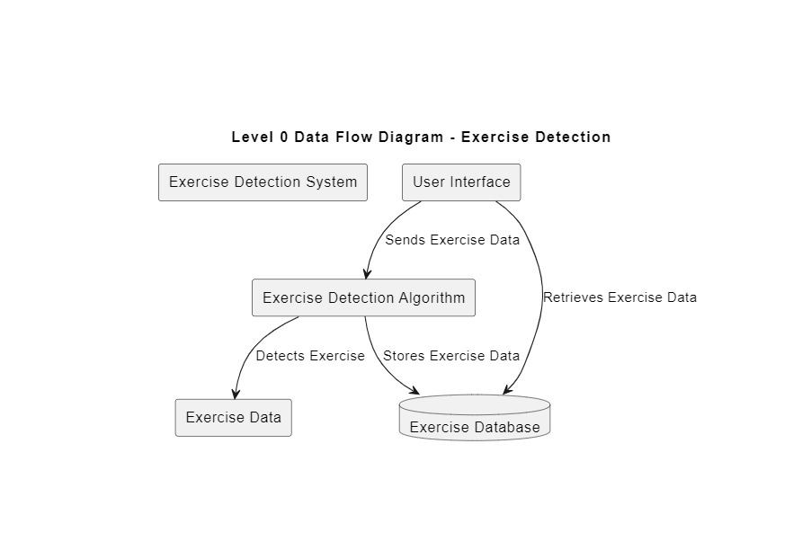

Diagram 5.1

**DFD Level 1:**

1-level DFD In 1-level DFD, a context diagram is decomposed into multiple bubbles/processes. In this level, we highlight the main objectives of the system and breakdown the high-level process of 0-level DFD into subprocesses.

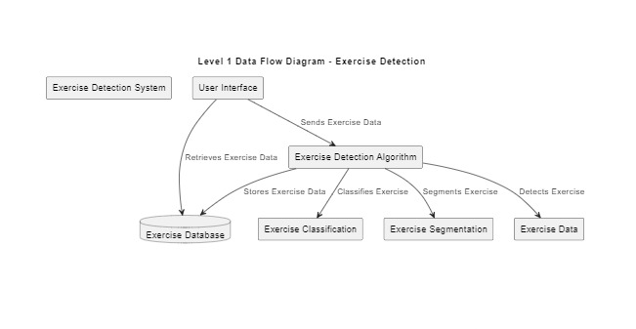

Diagram 5.2

**DFD Level 2:**

Deeper Dives (Level 2): the next level of DFDs provides even more detailed information by breaking down each Level 1 process into granular subprocesses. This level provides a deeper understanding of the system or process. It helps identify inefficiencies and areas for improvement.

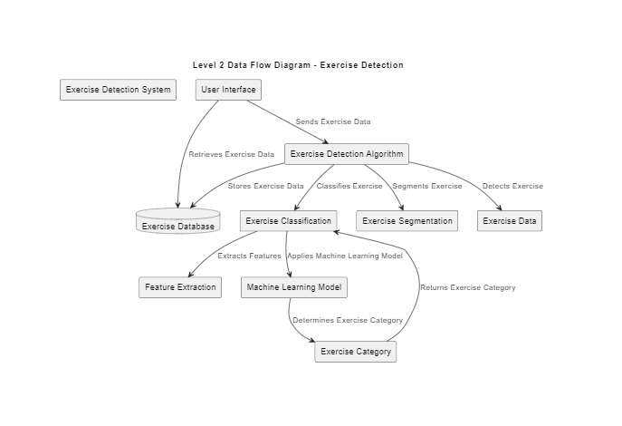

Diagram 5.3

1. **CLASS UML DIAGRAM**

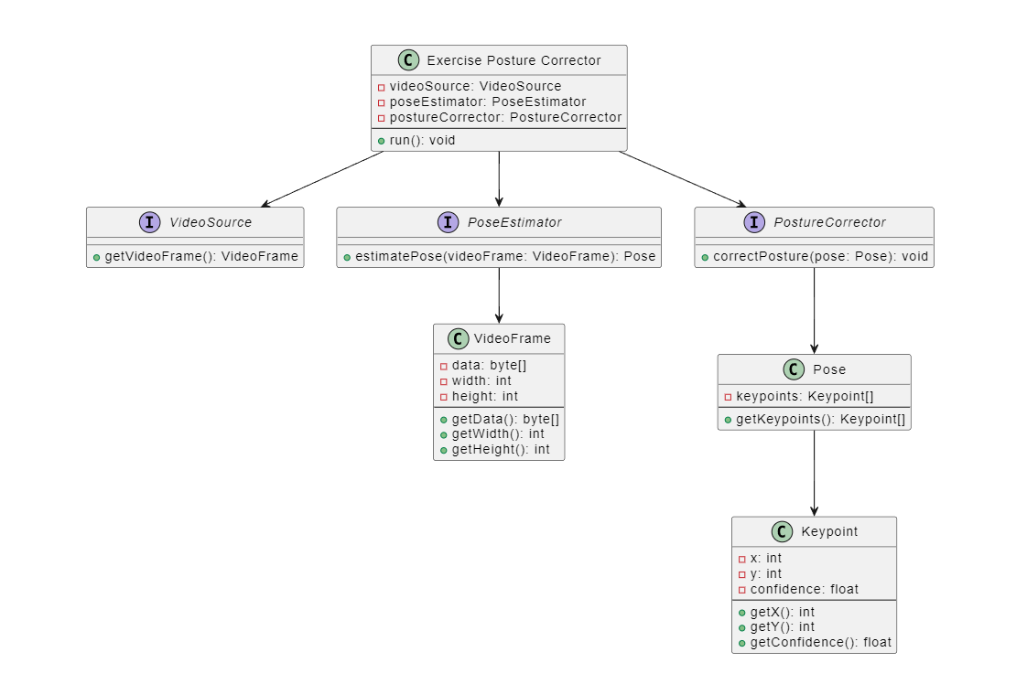

Diagram 5.4

1. **er diagram**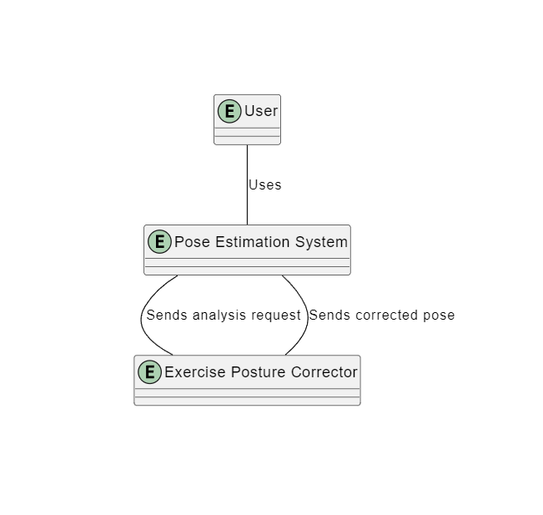

Diagram 5.5

1. **sequence uml diagram**

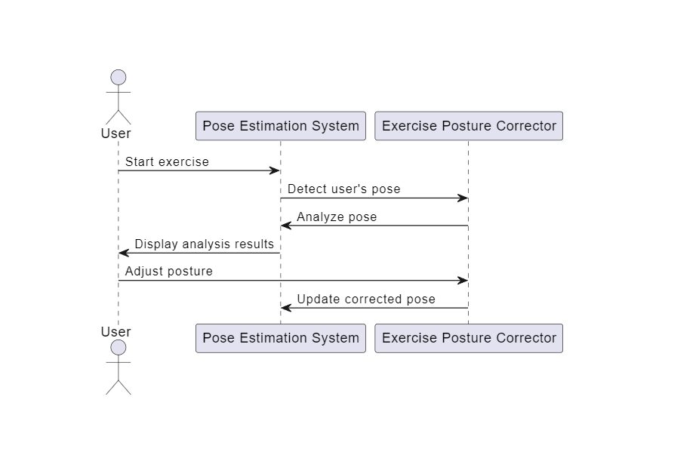

Diagram 5.6

1. **state uml diagram**

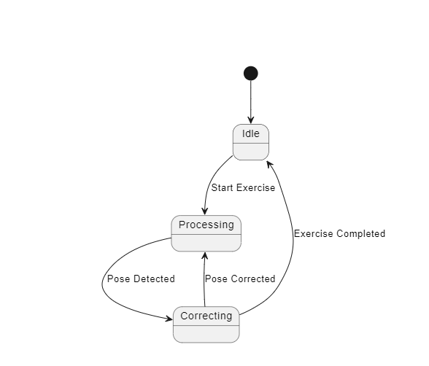

Diagram 5.7

**Chapter 6**

**PROJECT IMPLEMENTATION**

In the first stage of our project implementation, we are going to access the webcam and will detect the joints and connections of user. Then we will apply our logic to analyze whether the user is doing the exercise in right way or wrong way. Following are the steps and screenshots of the respective code.

1. **Install & Import Dependencies:**

We have installed the necessary libraries such as mediapipe and OpenCV as follows,

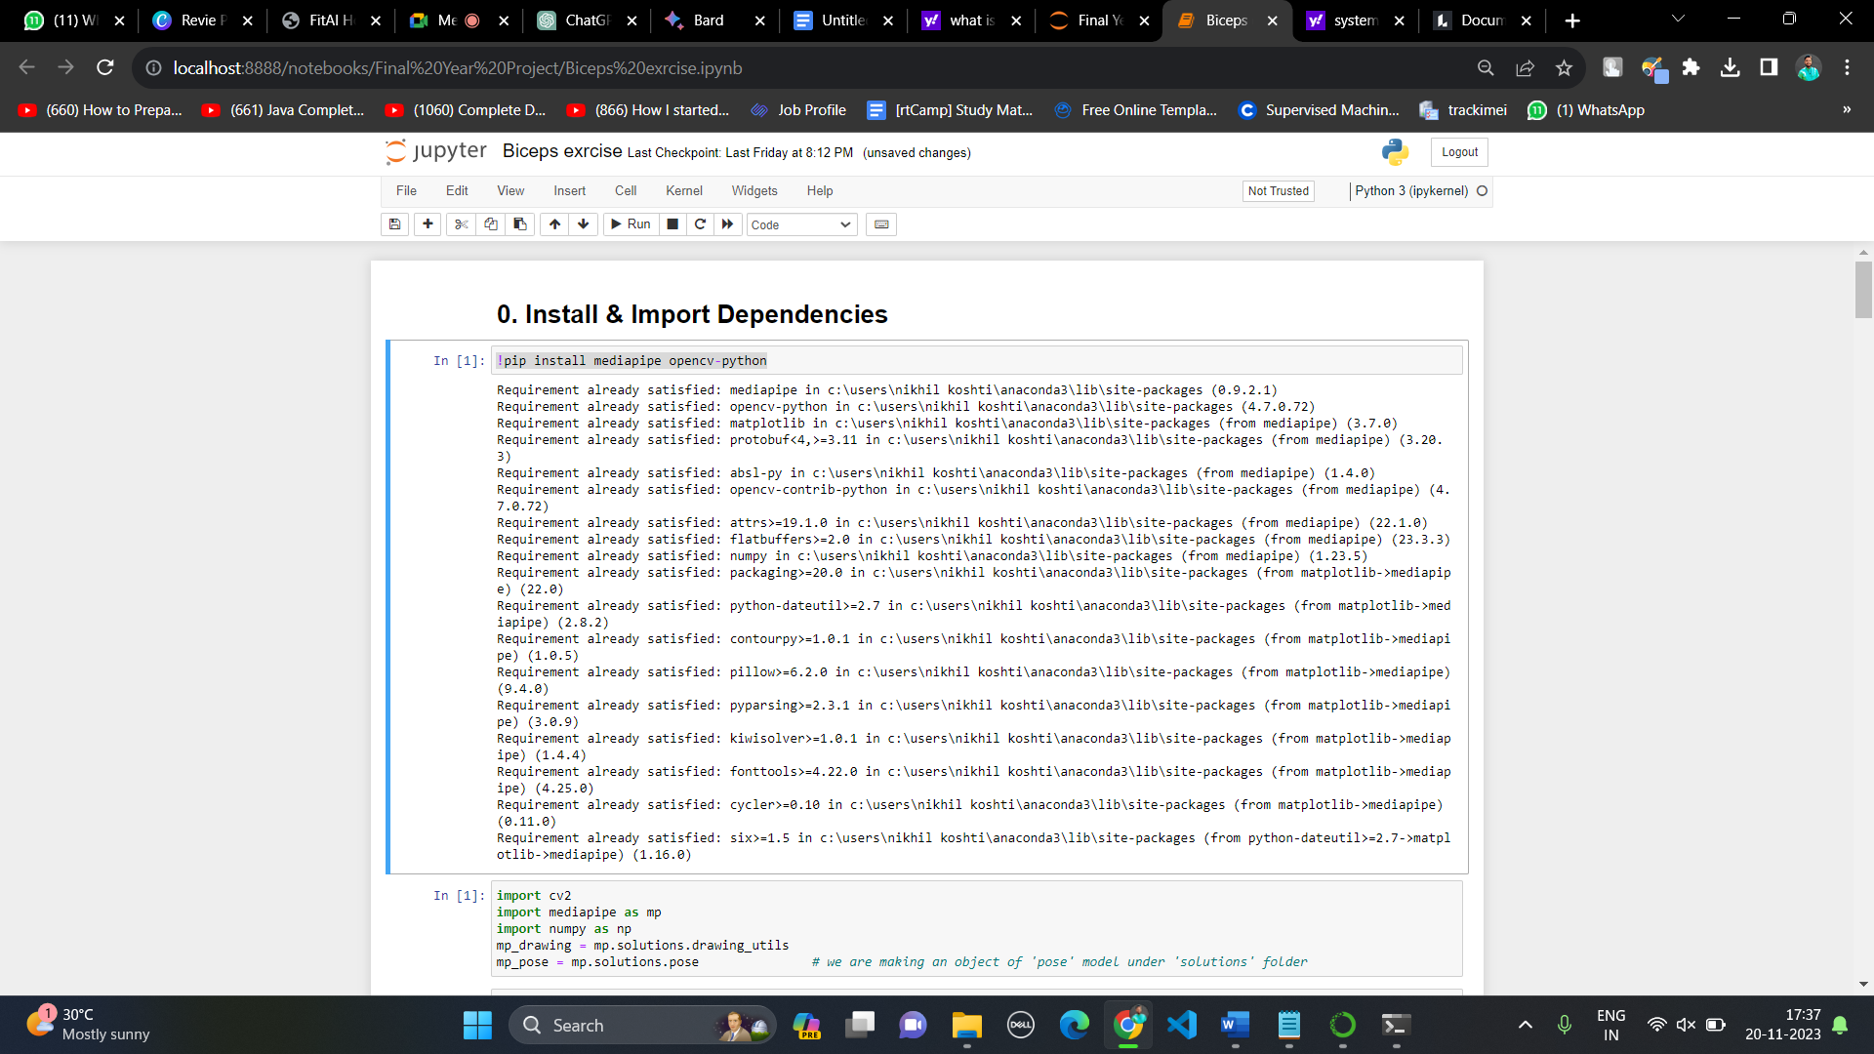

1. **Make Detections:**

In this we have used solution.Pose model to detect the joints and body parts such as shoulder, elbow, leg, etc.

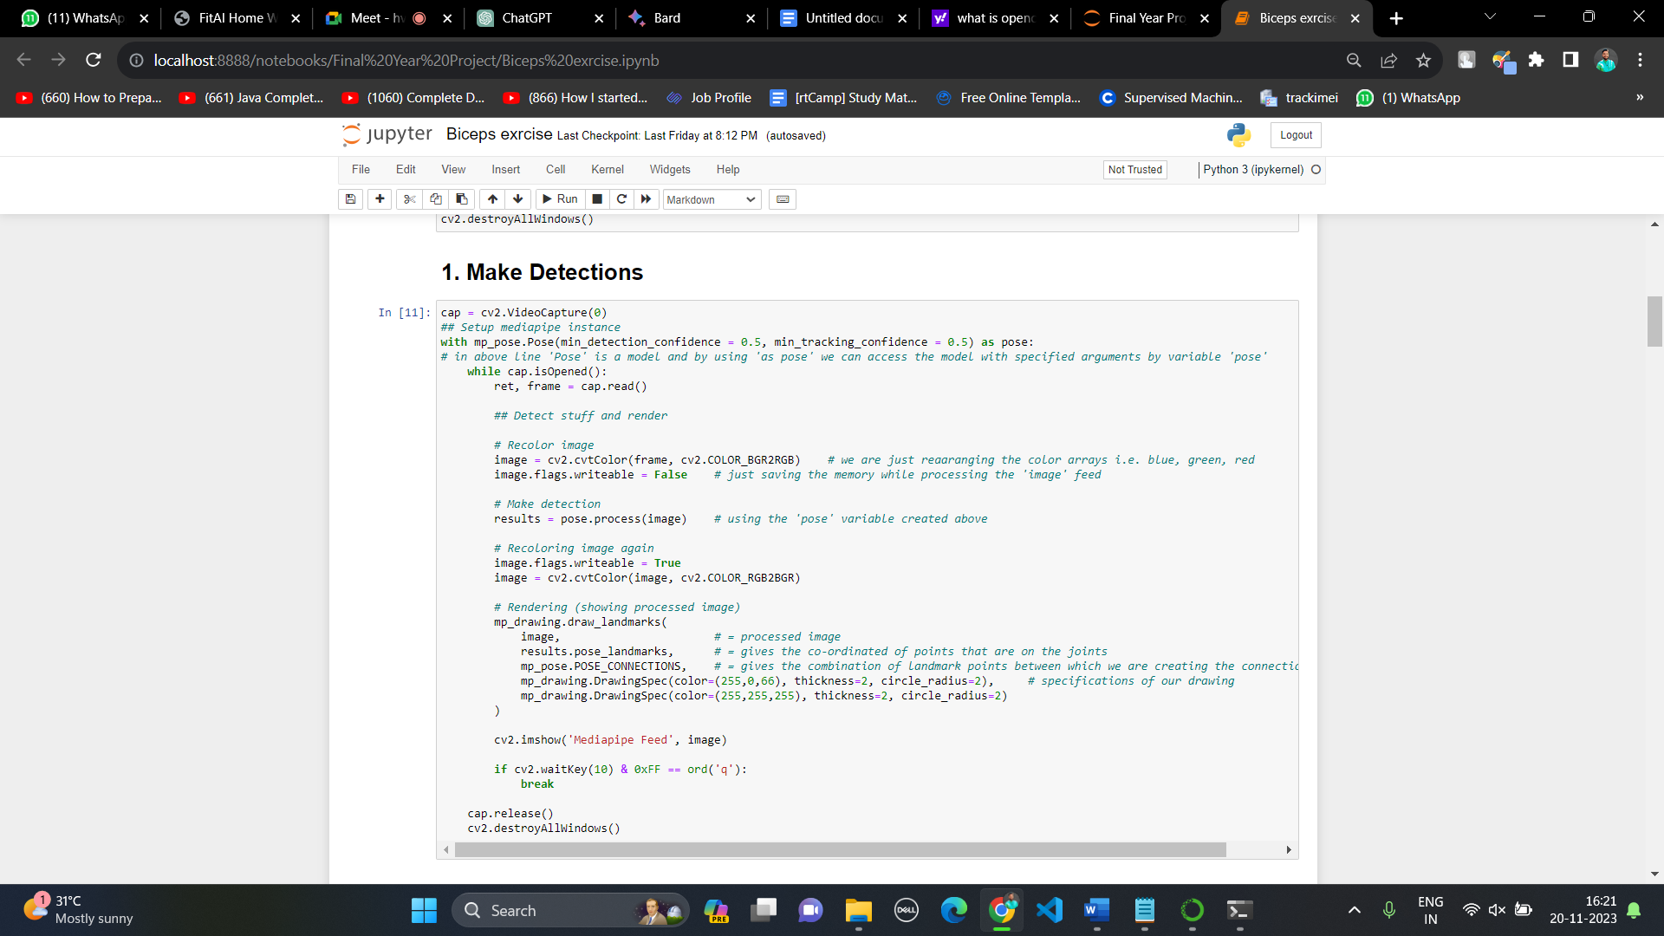

1. **Determining Joints:**

This we studied the Pose model. Means there are how many detection landmarks are available, how many connection lines are available and how we can retrieve that information. The pose model diagram is shown in Chapter 4 also.

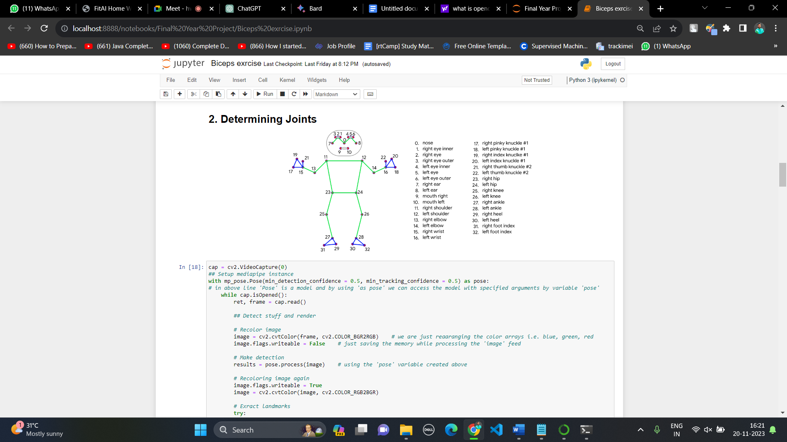

Retrieving the info.

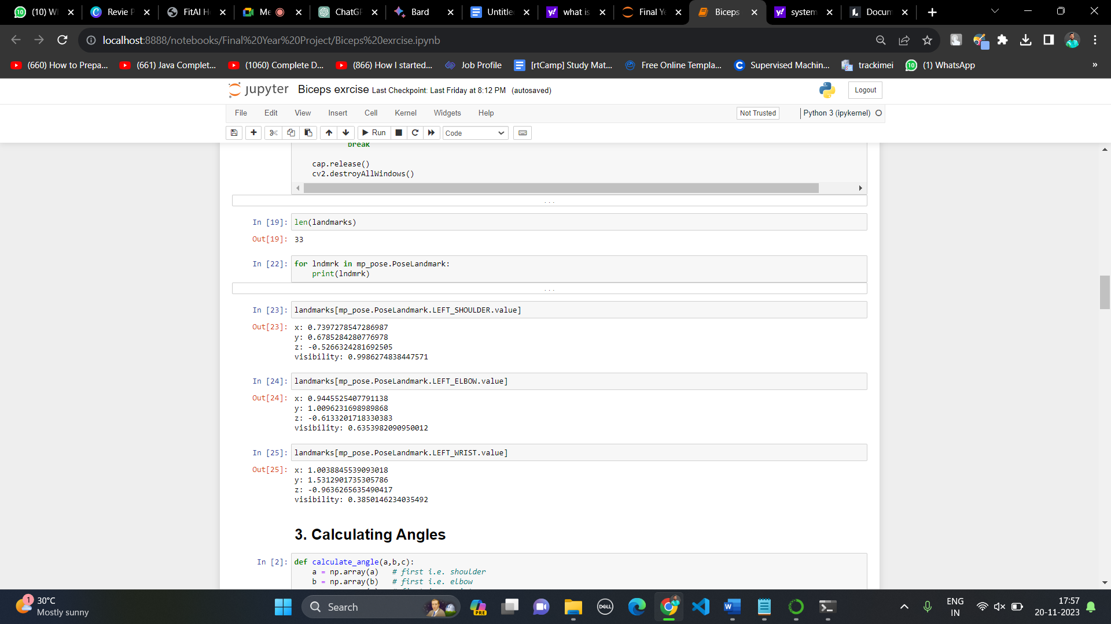

1. **Calculating Angles:**

In this I have written the calculate_angle() which takes the three point coordinates as parameters and returns the angle joining those point coordinates.

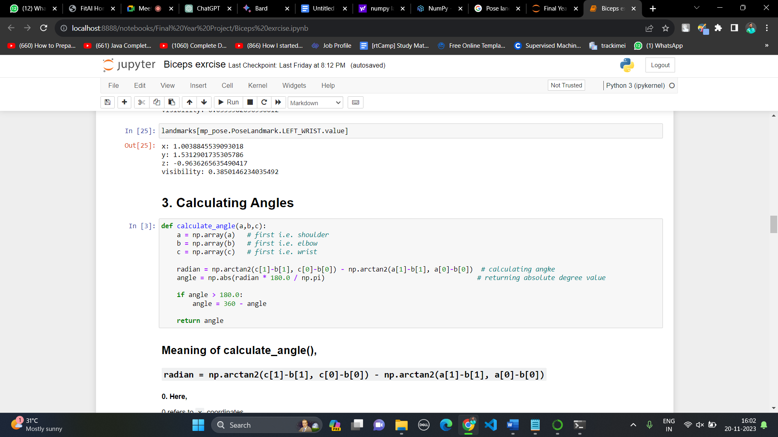

1. **Pose Perfector Logic:**

Let me explain it with an example.

We have considered the exercise of biceps in which two body angles are important that are angle at elbow and hip. So, I have given the threshold values to these angles and if the user crosses these thresholds our system will give an alert that you are doing it wrong.

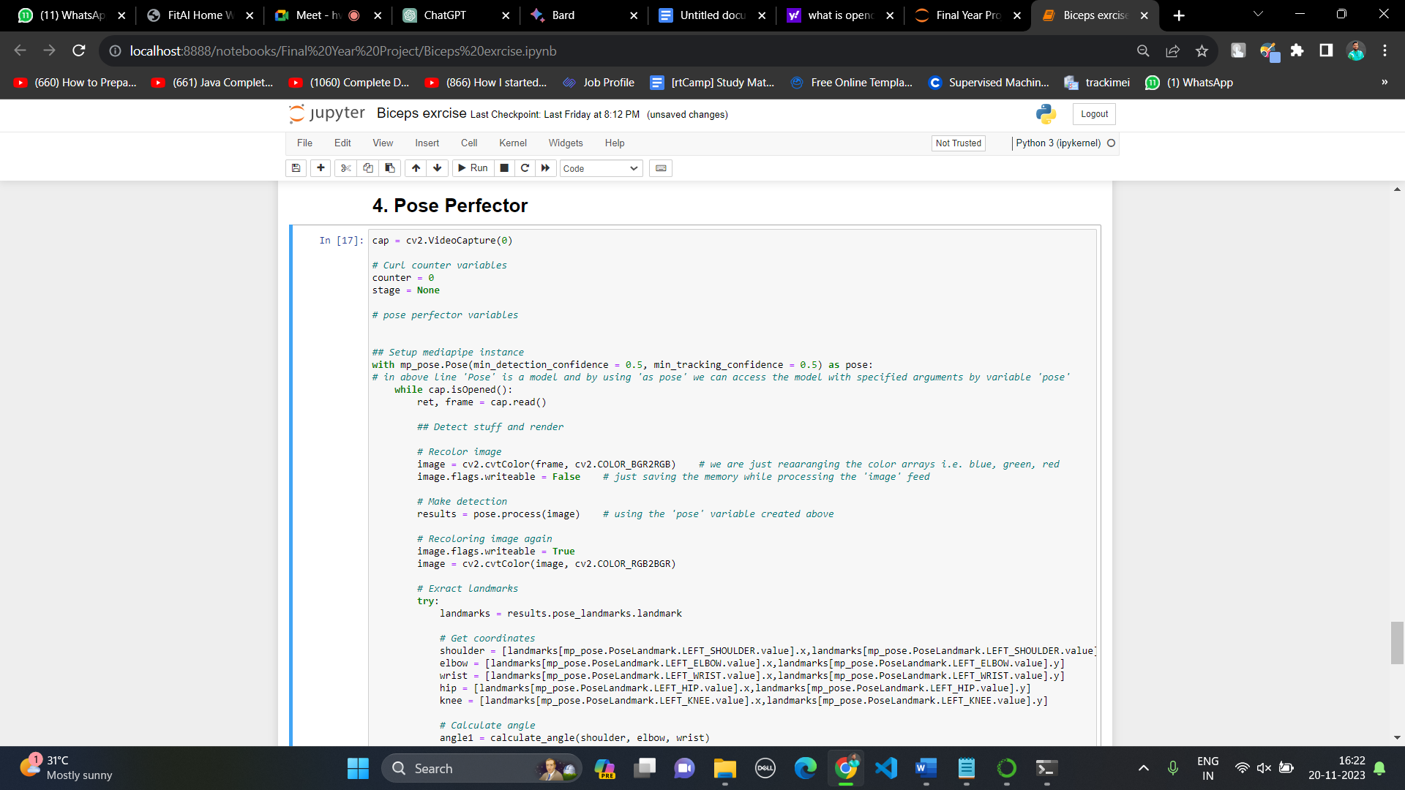

Logic for thresholds:

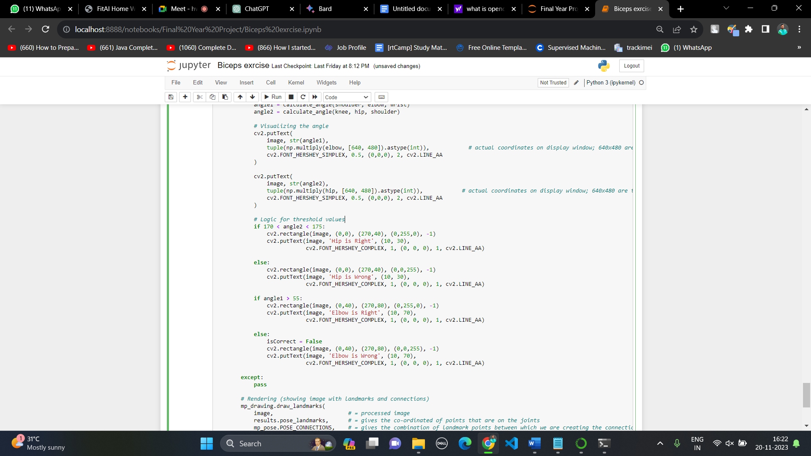

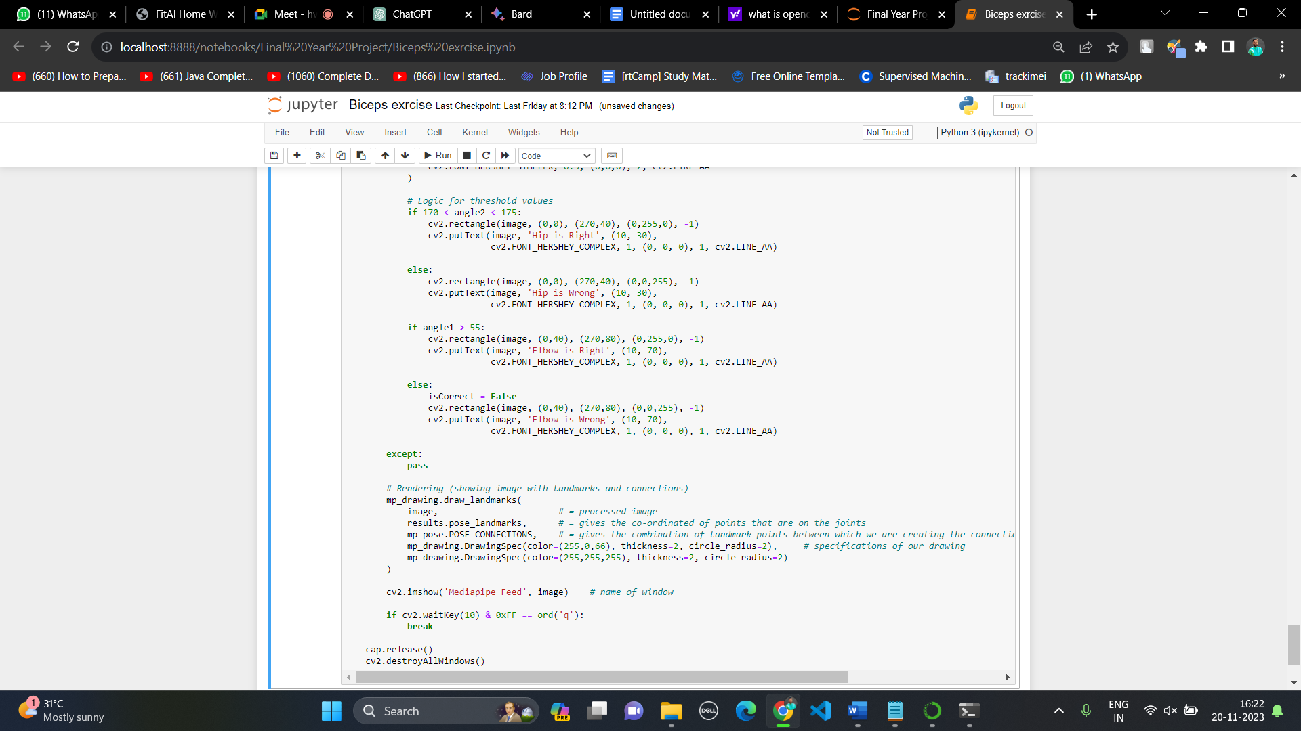

**Chapter 7**

**RESULTS**

Here we are going to share some result screenshots in which we have shown we are going to give alerts and information about the angles on which user have to focus.

In our example of biceps exercise there are two angles elbow and hip. We do display the measure of angle to the user as shown in following diagrams.

In the section there are 4 sections as follows,

1. Both angles are right

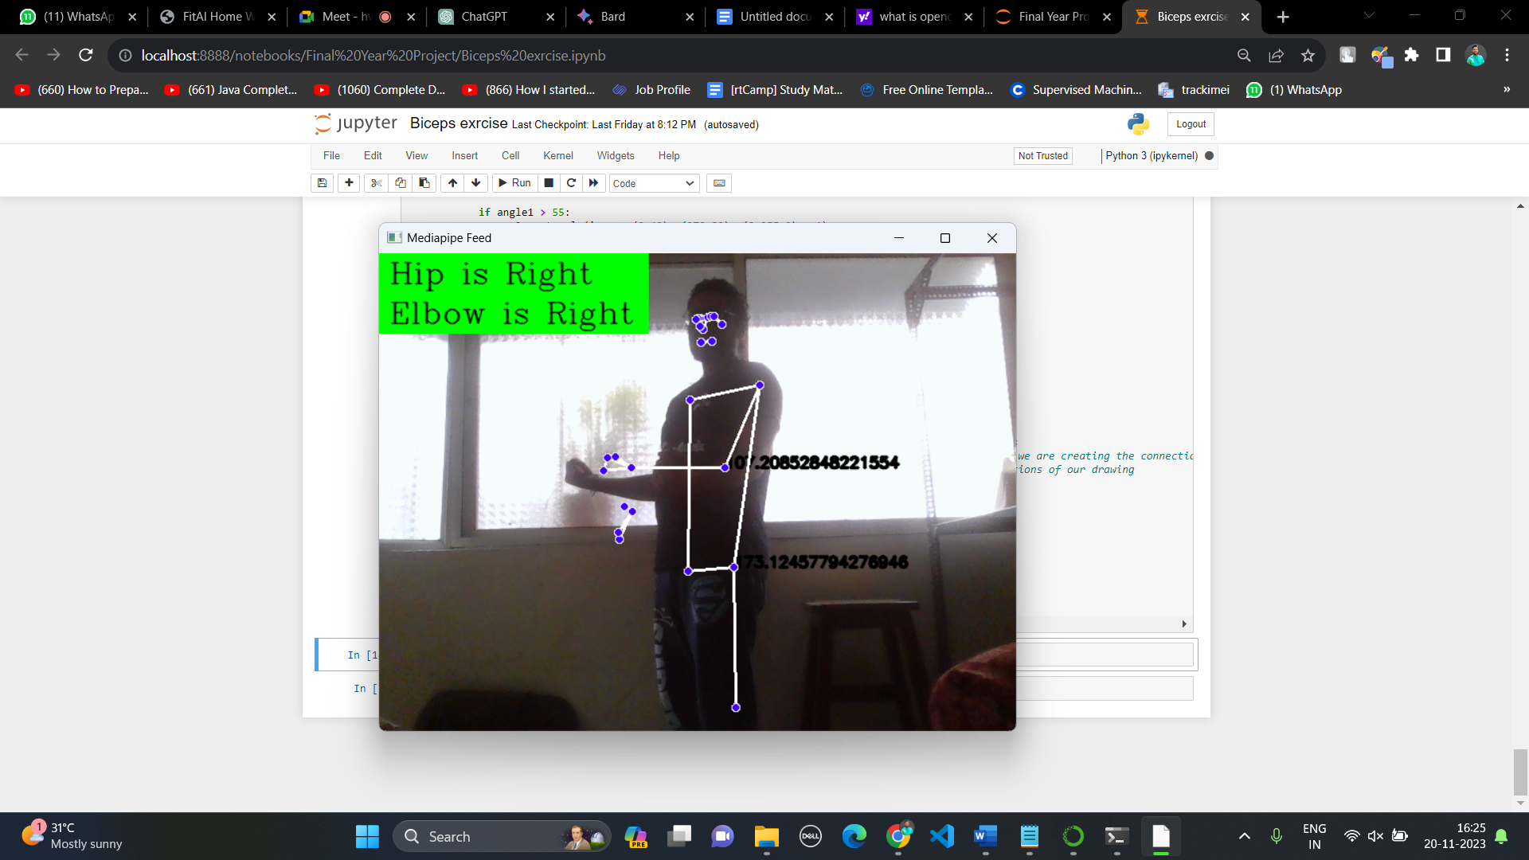

1. One of the angles is wrong

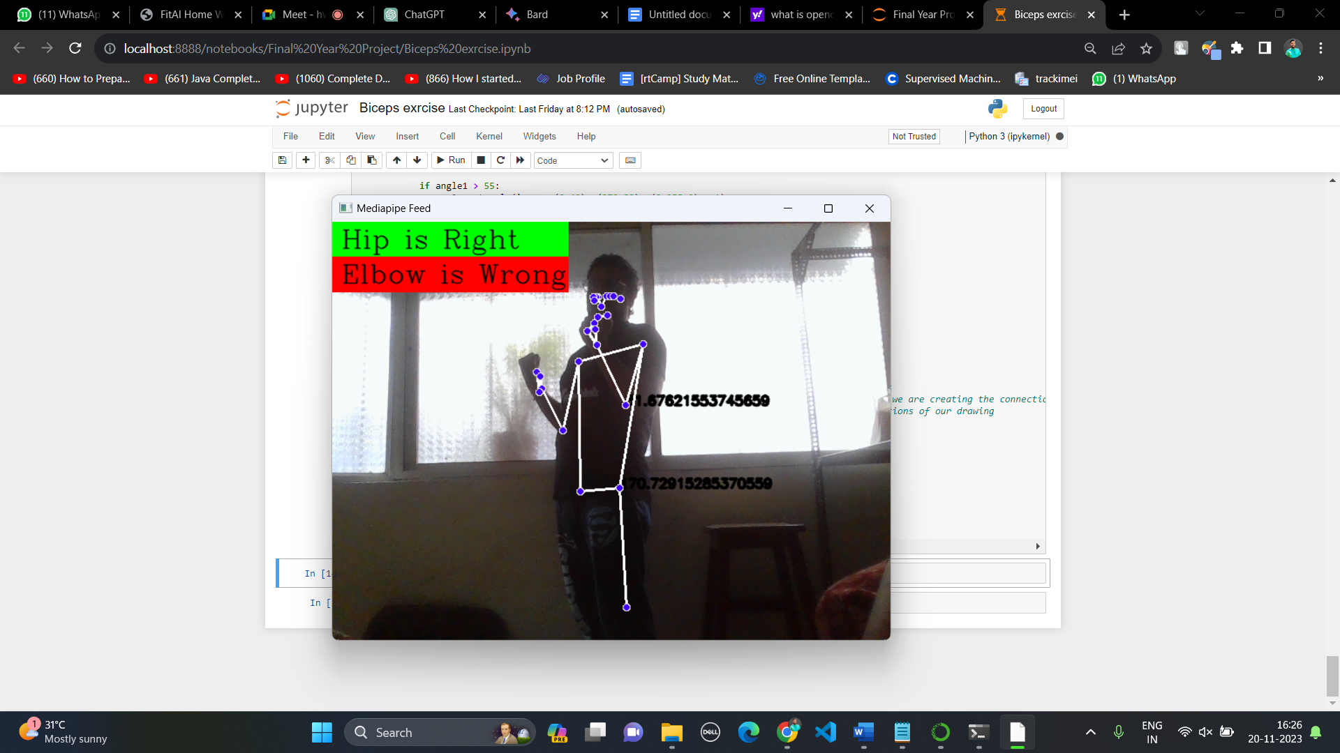

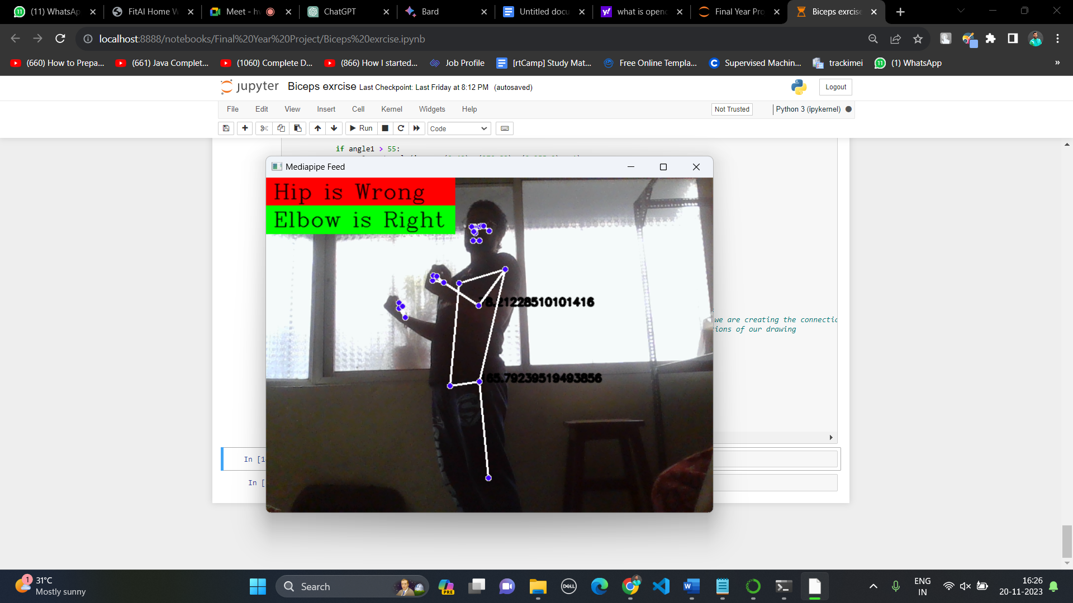

1. Both angles are wrong

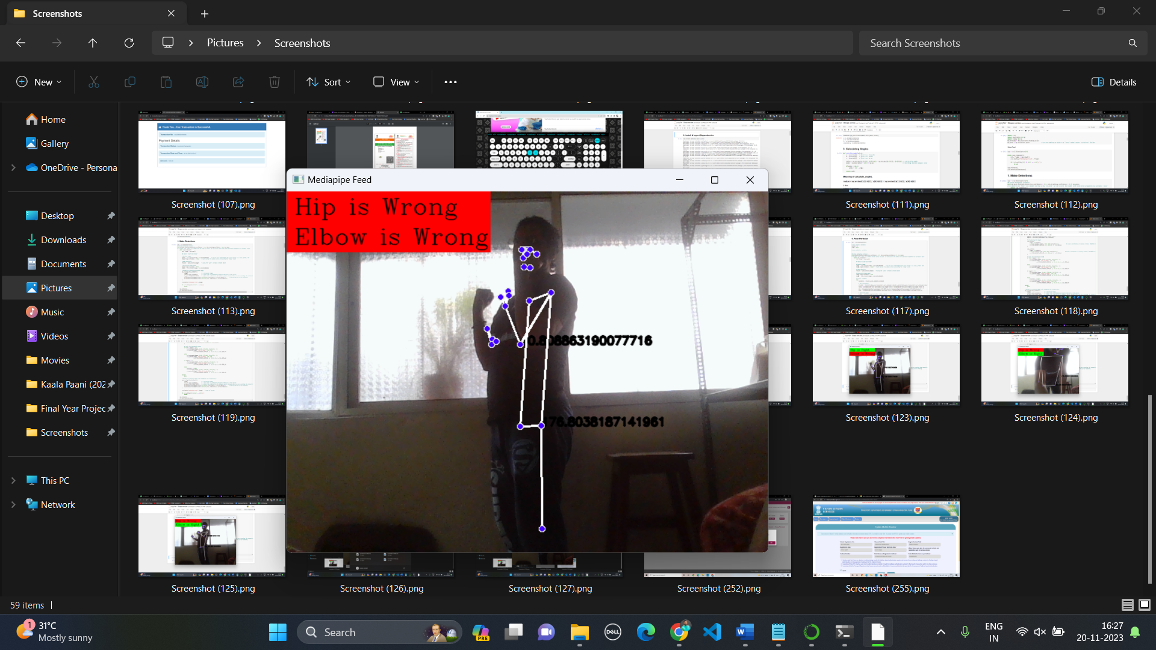

**Chapter 7**

**PLAGIARISM REPORT**

